Power Outage Forecasting and Backup Generator Preposition

95-828 MLPS Sections A and B
Lisa Chung, Olivia Brown, Chloe Bonson, and Seongsu Kim

1. Introduction
Power outages caused by severe weather remain a persistent challenge across the United States, straining emergency services, disrupting daily life, and inflicting economic harm. When outages can be anticipated even hours in advance, utilities gain the opportunity to act. They can position crews, alert communities, and deploy backup resources before conditions deteriorate.
This project tackles two connected problems. The first is forecasting hourly outage counts across Michigan's 83 counties at 24-hour and 48-hour horizons using only historical outages and observed weather data without access to future weather. The second is translating those forecasts into an actionable decision: selecting five counties to receive mobile backup generators, each supporting up to 1,000 households and fixed once deployed.

The training data spans roughly three months of hourly observations from spring to summer 2023, covering outage counts, household coverage per county, and 109 weather variables. The 109 weather variables include atmospheric, hydrological, and land-surface conditions such as wind gusts, temperature, precipitation, and soil moisture. The prediction target is the hourly outage count for each county, which is a heavily sparse variable, with roughly 70% of all county-hour observations recording zero outages.

We developed a zero-prediction baseline and SARIMAX as benchmarks, then built LightGBM, a Temporal Convolutional Network, and enhanced SARIMAX models. We combined the three models through a ridge stacking ensemble, which achieved the best performance on both horizons. The sections that follow describe our data analysis, modeling approach, results, and policy recommendation.

2. Data Analysis

2.1 Dataset Overview
The training dataset covers 2,161 consecutive hours from April 1, 2023 to June 30, 2023 across 83 counties with 109 original weather variables. Three arrays form the core of the dataset: hourly county outage counts (out), tracked households (tracked), and hourly county weather features (weather). The training period falls during storm season, which has direct implications for the distribution of outage events. Two test sets are provided for separate evaluation horizons: a 24 hour ahead prediction window and a 48 hour window.

The data is highly sparse: about 70.5% of county-hour entries are zero. Among hours that do, the distribution is heavily right-skewed: hours above the 90th percentile of non-zero outages account for 53.3% of total outage volume despite being a small fraction of all observations (See Figure 1). This pattern is visible in the time series too with long flat stretches of near-zero activity, then sudden sharp spikes corresponding to storms. Those spikes are rare, but contain the majority of the outages, making this project particularly challenging.

2.2 Weather Feature Analysis
We approach weather features by focusing on storm variables and using Principal Component Analysis (PCA) to decrease the total number of dimensions. First, PCA was applied globally across all data to compress the full weather feature space into 20 principal components, representing about 79.0% of the variance in the data. After that, weather variables whose names contain storm-relevant keywords such as wind, gust, precipitation, CAPE, and CIN were extracted separately, standardised, and summarised to their mean and maximum at each timestep. This provided all models with a compact storm signal alongside the broader PCA representation.

2.3 Additional Feature Transformations
We performed the following additional feature transformations:
Log Transformations. All model targets were log 1 transformed before training and converted back at prediction time. This keeps the scale consistent across counties so a county with thousands of outages doesn’t drown out the signal from a county with only a few. Log 1 transformation also helps with the large number of instances where there are 0 outages.
Outage rate. We calculated a ratio of outages log plus 1transformed over the number of tracked households also log plus 1 transformed to produce a size-normalised signal comparable across counties regardless of population. A lagged version of this rate was included as a model feature.
Lag features. Past log-outage values at lags of 1, 2, 3, 6, 12, 24, and 48 hours were constructed per county, giving models direct access to recent outage history.
Rolling statistics. Rolling mean, maximum, and standard deviation of log-outages were computed over windows of 6, 12, 24, and 72 hours using vectorised operations, producing 12 features that capture recent trend, volatility, and peak activity.
Storm flag. A binary feature was derived that activates when the 6-hour rolling maximum outage exceeds twice the 168-hour rolling mean plus a small additive buffer. This encodes storm onset as a sudden escalation relative to recent baseline activity.
Time encodings. Hour of day, day of week, and month were converted into a circular format using sine-cosine pairs so that 11pm and midnight are close together, and that December and January are close together instead of treating them as opposite ends of a scale.
All normalisation statistics were computed exclusively on the training partition and applied identically to the validation and test data.

3. Methods
Our goal was to forecast county-level power outages in Michigan at the 24-hour and 48-hour horizons. This is not only a time-series forecasting problem, but also a sparse count forecasting problem: most observations are zero, while the most operationally important events appear as relatively rare spikes. Under this structure, we did not expect a single model family to capture all patterns equally well. Some models are better at learning temporal dependence, while others are better at using engineered predictors. We therefore compared several model families and ultimately combined complementary models in an ensemble.
Our model selection principle was simple: a more complex model was retained only if it provided clear added value over simpler baselines. In sparse, spike-driven settings, flexible models can easily become unstable or overfit the majority of near-zero observations. Accordingly, we began with the baselines provided in the official demo notebook, then evaluated classical time-series, feature-based boosting, and deep sequence models, and selected the final models based on validation performance and complementarity.

3.1 Baseline Models
We began with the baselines provided in the official demo notebook. The first was a zero baseline, which predicts zero outages for every county-hour. Although simple, this is an important benchmark because a large share of the data is in fact zero. The second was a simple SARIMAX(1,0,1) model using only past outage history. This served as a classical benchmark for how much predictive value can be extracted from temporal autocorrelation alone, without weather inputs or extensive feature engineering.
Evaluated on the final 20% of the training period with no additional features, the zero baseline achieved a 24-hour RMSE of 100.31, while the simple SARIMAX baseline improved this to 89.75. This showed that even a relatively simple time-series model could meaningfully outperform the trivial benchmark.

3.2 Early Model Exploration and Selection Logic
After establishing the baselines, we explored more expressive models. In early experiments, we also examined a simple recurrent neural forecasting approach based on the demo notebook setup. However, this initial sequence model did not reliably outperform the baselines on this sparse, spike-driven task. This suggests that deep learning is not automatically the best choice, especially when the target distribution is dominated by zeros and the most important signals are rare extreme events.
We therefore prioritized validation performance, stability, and strong feature engineering over model complexity itself. As a result, we retained three final model families with competitive performance and distinct strengths: LightGBM, TCN, and SARIMAX. Approaches that did not show clear incremental value over the baselines were excluded from the final model set.

3.3 Model A: LightGBM MIMO
The first final model was LightGBM, selected because it can effectively use the structured predictors developed in our feature engineering pipeline, including lag features, rolling statistics, outage rate, storm indicators, and PCA-compressed weather information. In sparse forecasting tasks, features that summarize recent level, trend, volatility, and abrupt escalation are often highly informative, and LightGBM is well suited to exploiting them.
Rather than training a separate model for each forecast step, we used a multi-input multi-output (MIMO) design that predicts the full horizon at once. This uses the data more efficiently and helps generate more coherent 24-hour or 48-hour forecast paths. In our final system, LightGBM represents the model that makes the strongest use of engineered features.

3.4 Model B: Temporal Convolutional Network (TCN)
The second final model was a TCN. Although the initial recurrent approach was not retained, we did not discard deep sequence modeling entirely because outage events are inherently temporal and often build over time. However, the simple recurrent setup appeared less stable in this sparse, spike-driven setting, so a more reliable sequence architecture was needed.
We therefore used TCN instead of LSTM. TCN can capture longer temporal patterns efficiently and often trains more stably than standard recurrent models. It therefore serves as the deep temporal model in our final system, complementing LightGBM by learning sequential structure more directly rather than relying mainly on hand-crafted features.

3.5 Model C: SARIMAX
The third final model was county-level SARIMAX. We retained this model because the baseline comparison already showed that classical time-series structure was relevant in this problem. If even a simple SARIMAX could outperform the zero baseline, then a richer version with better seasonal structure and limited weather information remained a strong candidate.
In the final SARIMAX specification, we did not include all raw weather variables directly. Instead, we used a PCA-based weather summary as an exogenous input. This helped preserve some weather information while avoiding unnecessary instability in county-level models with limited sample size. SARIMAX therefore served as a classical anchor model that balanced interpretability and predictive competitiveness.

3.6 Ensemble Rationale
Our final submission model was a stacking ensemble combining our LightGBM, TCN, and SARIMAX. We did not choose a single best model because the three models capture different aspects of the data. LightGBM is strongest on engineered features and sparse tabular structure, TCN learns temporal dynamics directly from recent history, and SARIMAX captures county-specific autocorrelation and spikes effectively. Combining them reduces reliance on any one modeling assumption.
For the meta-model, we used ridge stacking. Because county-level validation samples are limited, we preferred a simple and stable combiner over a more flexible meta-learner that could overfit. The ensemble achieved better validation performance than the individual models and was therefore selected as the final forecasting model. In other words, the key methodological conclusion of this project is not that one highly complex model solved the task, but that combining complementary model families was the most effective strategy for this problem.

4. Results

4.1 Overall Final Validation Performance
The ensemble outperforms all individual models on both horizons. On its own, SARIMAX produces RMSEs of 33.50 and 35.89 for the 24-hour and 48-hour horizons respectively, which is worse than the zero baseline (See Table 1 and Figure 2). This is likely because SARIMAX fits a simple time series per county and ends up predicting small nonzero values during quiet periods, which adds up to more error than just guessing zero. Despite this, SARIMAX still adds value to the ensemble, which achieves the lowest RMSE overall, through better capture of spikes.

Among the individual models, both TCN and LightGBM beat the zero baseline on both the 24-hour and 48-hour horizons. Both remain relatively stable, with TCN deteriorating slightly from 22.48 to 22.92 and LightGBM from 21.82 to 22.85 (See Table 1 and Figure 2). This stability is architecturally motivated for both models. LightGBM uses a MIMO design, training a single model per county to output all horizon steps at once rather than compounding sequential predictions. Similarly, TCN produces the full forecast horizon in a single forward pass through its causal convolutional layers, meaning it also avoids the error accumulation that plagues autoregressive approaches like SARIMAX. Overall, every model does worse at 48 hours than 24 hours, which is expected as forecast uncertainty naturally increases with time.

4.2 Spike Performance
We defined spike events as county-hours where the true outage exceeded the 90th percentile of non-zero validation observations, corresponding to a threshold of roughly 162 outages. When it comes to spike events, all the models struggle significantly compared to overall performance. That said, SARIMAX had the lowest spike RMSE among the three individual models at 352.95, which means it actually captures extreme outage behavior better than TCN or LightGBM despite performing worse than the zero baseline overall (See Table 2) . This is a key reason we retained it in the ensemble. The ensemble still performs the best with a spike RMSE of 254.76, which is roughly half the zero baseline's 519.29. However, 254.76 is still a large number, which shows that predicting rare, extreme outage events is fundamentally difficult when the training data is dominated by quiet periods. This is consistent with the training data distribution described in Section 2.1. This is especially relevant for the policy recommendation since spikes are exactly the kind of events that pre-positioned generators are meant to address.

4.3 Validation Plots
Figure 3 in the appendix shows the 24-hour validation predictions for the five recommended counties. The ensemble in red follows the ground truth in black most closely out of all the models, producing the most stable and accurate forecasts across all five counties. In contrast, the TCN and LightGBM tend to overshoot or undershoot, especially in the early hours. The main takeaway from these plots is that none of the models capture sudden spikes well. For example, county 26093 has a sharp outage surge between hours 5 and 10 that every model completely misses. This is consistent with the spike RMSE results – our models can identify which counties are at higher risk, but they underestimate how bad the worst outages actually get.

5. Analysis and Policy Recommendation

5.1 What the Predictions Are, and Are Not, Reliable For
The ensemble's overall validation RMSE of 14.24 (24h) and 19.18 (48h) is an average across all 83 counties and all hours, including the majority of county-hours where outages are zero and prediction is trivially easy. From a decision-making perspective, this headline number is misleading.The spike RMSE for the high-outage events that drive operational decisions is 254.76, roughly 18 times larger. A decision-maker who interprets the overall RMSE as a measure of forecast reliability for storm response planning would dramatically overestimate the model's usefulness precisely when it matters most.
The more honest characterization is that the model is reliable for predicting the absence of significant outages and provides a weak but real signal about which counties face elevated risk in an event. It should not be treated as a precise quantitative forecast of outage magnitude during storm conditions. This distinction is central to the policy recommendation that follows: we use the forecasts as a relative prioritization signal rather than trust point predictions at face value.

5.2 Horizon-Dependent Reliability and Its Policy Implications
The gap between 24-hour and 48-hour performance is modest across models, indicating that predictive accuracy degrades only slightly at longer horizons. The TCN’s RMSE increases from 22.48 to 22.92 (approximately +2%), while LightGBM rises from 21.82 to 22.85 (approximately +5%). This suggests that both models rely on features whose predictive signal persists reasonably well over 48 hours, rather than rapidly decaying temporal dynamics.
From a policy perspective, this implies that 48-hour forecasts retain meaningful informational value and should not be dismissed outright. However, the consistently stronger performance at the 24-hour horizon still justifies placing greater weight on nearer-term predictions when making operational decisions such as generator pre-positioning. Accordingly, we incorporate both horizons into our prioritization framework, but weight the 24-hour forecasts more heavily while still using the broader situational awareness provided by the 48-hour signal.

5.3 Structural Limitations
Two structural limitations apply across all models. First, no forward-looking weather information is available during the test period. SARIMAX holds the last observed weather value constant across forecast steps, and the TCN and LightGBM rely only on lagged history. All models therefore can only react to a storm after it has begun affecting the grid. Incorporating operational numerical weather prediction forecasts, available up to 5–7 days ahead, would likely be the most impactful improvement for any operational deployment, particularly at the 48-hour horizon.
Second, all predictions are made at the county level. Counties vary enormously in size and population density, so a county-level forecast cannot indicate where within a county outages will concentrate. This limits the spatial precision of any deployment decision and should be supplemented with local infrastructure data in practice.

5.4 Pre-positioning Backup Generators
Given these modeling realities, determining where to pre-position five mobile backup generators becomes a resource allocation problem under uncertainty. We did not simply select the counties with the largest predicted outages. Instead, we prioritized counties where the marginal utility of assigning one additional generator was greatest, where one more generator would create the greatest additional benefit relative to the county's existing capacity and baseline risk.
Our county prioritization rule combined two components. The first was predicted impact, reflecting the amount of outage that one generator could realistically mitigate under its 1,000-household capacity constraint. The second was a surge factor, reflecting how abnormal the predicted outage escalation is relative to the county's recent baseline. The final score is computed as predicted impact × surge adjustment, so counties rank highly when one generator can mitigate substantial outage and the predicted event is unusually severe relative to that county’s recent baseline. This scoring rule prevents the ranking from being driven solely by the largest counties and helps capture smaller counties entering unusually severe events.

5.5 Recommended Counties
Our final recommendation is [26115, 26163, 26125, 26093, 26099]. As shown in Appendix Table 3, the top five counties are Monroe, Wayne, Oakland, Livingston, and Macomb, with Washtenaw sixth for comparison.
“Served 24h” and “Served 48h” in Table 3 represent the cumulative household-hours one generator could provide over each horizon. The reported score combines practical mitigation potential and abnormal surge risk, with the 48-hour signal down-weighted based on the reliability analysis above.
Monroe County (26115) ranks first because it shows the highest immediate mitigation potential despite being relatively small in population. Its large Served 24h value suggests an unusually severe short-term surge, and a smaller county with less standing response capacity stands to gain the most from one additional generator.
Wayne County (26163) ranks second for a different reason. As the largest county by far, with about 922,000 tracked households, the absolute scale of disruption is substantial even though one generator covers only a small share. Outages in a large urban county are also more likely to cascade across hospitals, transportation, and other critical systems.
Oakland County (26125) ranks third because it is consistently high across both horizons, making it a stable high-risk county rather than one driven by a short-lived spike.
Livingston (26093) and Macomb (26099) are notable because their 24-hour values are modest while their 48-hour values are very large, suggesting the storm’s impact may intensify in these counties as the event develops. Despite the 48-hour down-weighting, both counties remained in the top five, suggesting a meaningful delayed risk signal rather than forecast noise.

5.6 Why One Generator Per County
Although the assignment allows multiple generators in the same county, we recommend distributing one generator to each of the five counties. The score drop from the fifth-ranked county (Macomb, 0.252) to the sixth (Washtenaw, 0.082) is substantial, indicating a clear separation between the top five and the rest. Distributing generators also hedges against forecast and storm-path uncertainty: if the event evolves differently than predicted, at least some generators are more likely to be near the most severely affected areas. Finally, in a constrained allocation setting, the marginal utility of placing a first generator in an unserved high-priority county is generally greater than adding a second to one that already has one, especially when spike magnitudes are hard to predict precisely.

5.7 Limitations and Operational Interpretation
This recommendation should be interpreted as a relative prioritization signal, not a precise estimate of outage magnitude. We also checked sensitivity: with or without the surge adjustment, the top five counties were identical and the rank ordering across all 83 counties remained highly correlated, suggesting the recommendation is robust to the specific scoring formula.
In operational deployment, a utility should combine this model-based prioritization with real-time weather forecasts and local infrastructure information such as hospitals, nursing homes, shelters, and population density to determine both which counties receive generators and where within each county to place them. Even with these caveats, our recommendation improves on a simple ranking by predicted outage count because it accounts for generator capacity constraints, horizon-specific reliability, abnormal surge behavior, and robustness to alternative scoring rules.

5.8 Ethical Considerations
This project involves resource allocation decisions that directly affect households' access to power during emergencies, and several ethical dimensions warrant acknowledgment. The training data spans only spring and summer 2023, meaning the models reflect outage patterns from a single storm season, and communities whose outage histories are underrepresented due to data collection gaps or historically lower utility investment may be systematically disadvantaged by a model that treats this limited distribution as ground truth. The county-level granularity of predictions further obscures within-county inequality, as a forecast assigned to Wayne County cannot distinguish between neighborhoods with robust infrastructure and low-income communities with aging grid assets and fewer recovery resources.
That said, several design choices partially mitigate concentration risk. The surge adjustment in the scoring rule explicitly prevents the ranking from being dominated by the largest counties, ensuring that smaller counties facing unusually severe events remain competitive for generator assignment. Distributing one generator across each of the five counties rather than concentrating resources hedges against forecast uncertainty and broadens geographic coverage. The deliberate framing of model output as a relative prioritization signal rather than a precise quantitative forecast, together with the explicit reporting of spike RMSE alongside overall RMSE, guards against overconfident misuse by decision-makers. Finally, Section 5.7 recommends supplementing model scores with local infrastructure data such as hospitals, nursing homes, and shelters, which helps direct attention toward vulnerable populations even though the model itself does not encode demographic information. Any operational deployment should still involve domain experts, utility stakeholders, and affected communities in the decision loop rather than treating model output as a self-sufficient authority.

References

Anthropic. (2026). Claude [Large language model]. https://claude.ai/share/35186481-ecf7-4c6b-9369-8f0a2ebb5cf2

​​Brown, O., Bonson, C., Chung, L., Kim S. (2026). outage_forecast_v2.ipynb [Jupyter notebook, Google Colab]. Course project, 95-828 Machine Learning for Problem Solving, Carnegie Mellon University.

Appendix

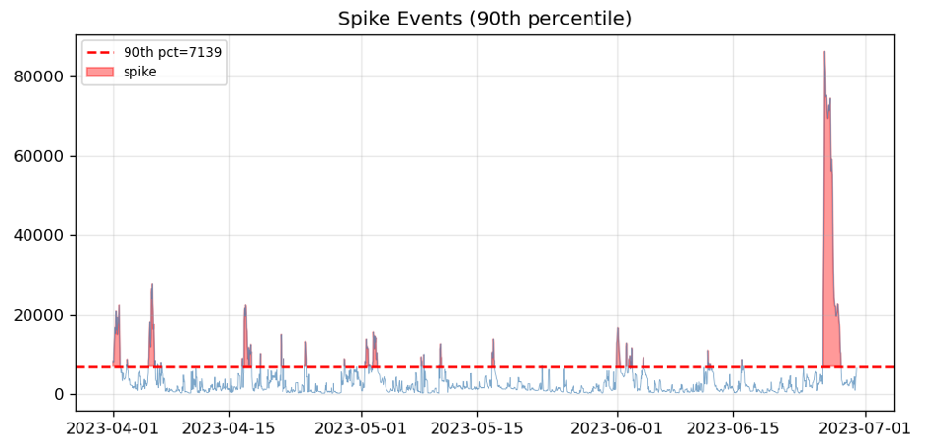

Figure 1. Spikes over the 90th percentile over time

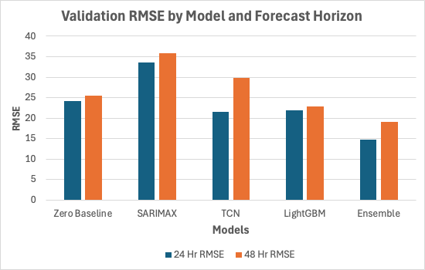
Figure 2. Validation RMSE comparison across models for both forecast horizons
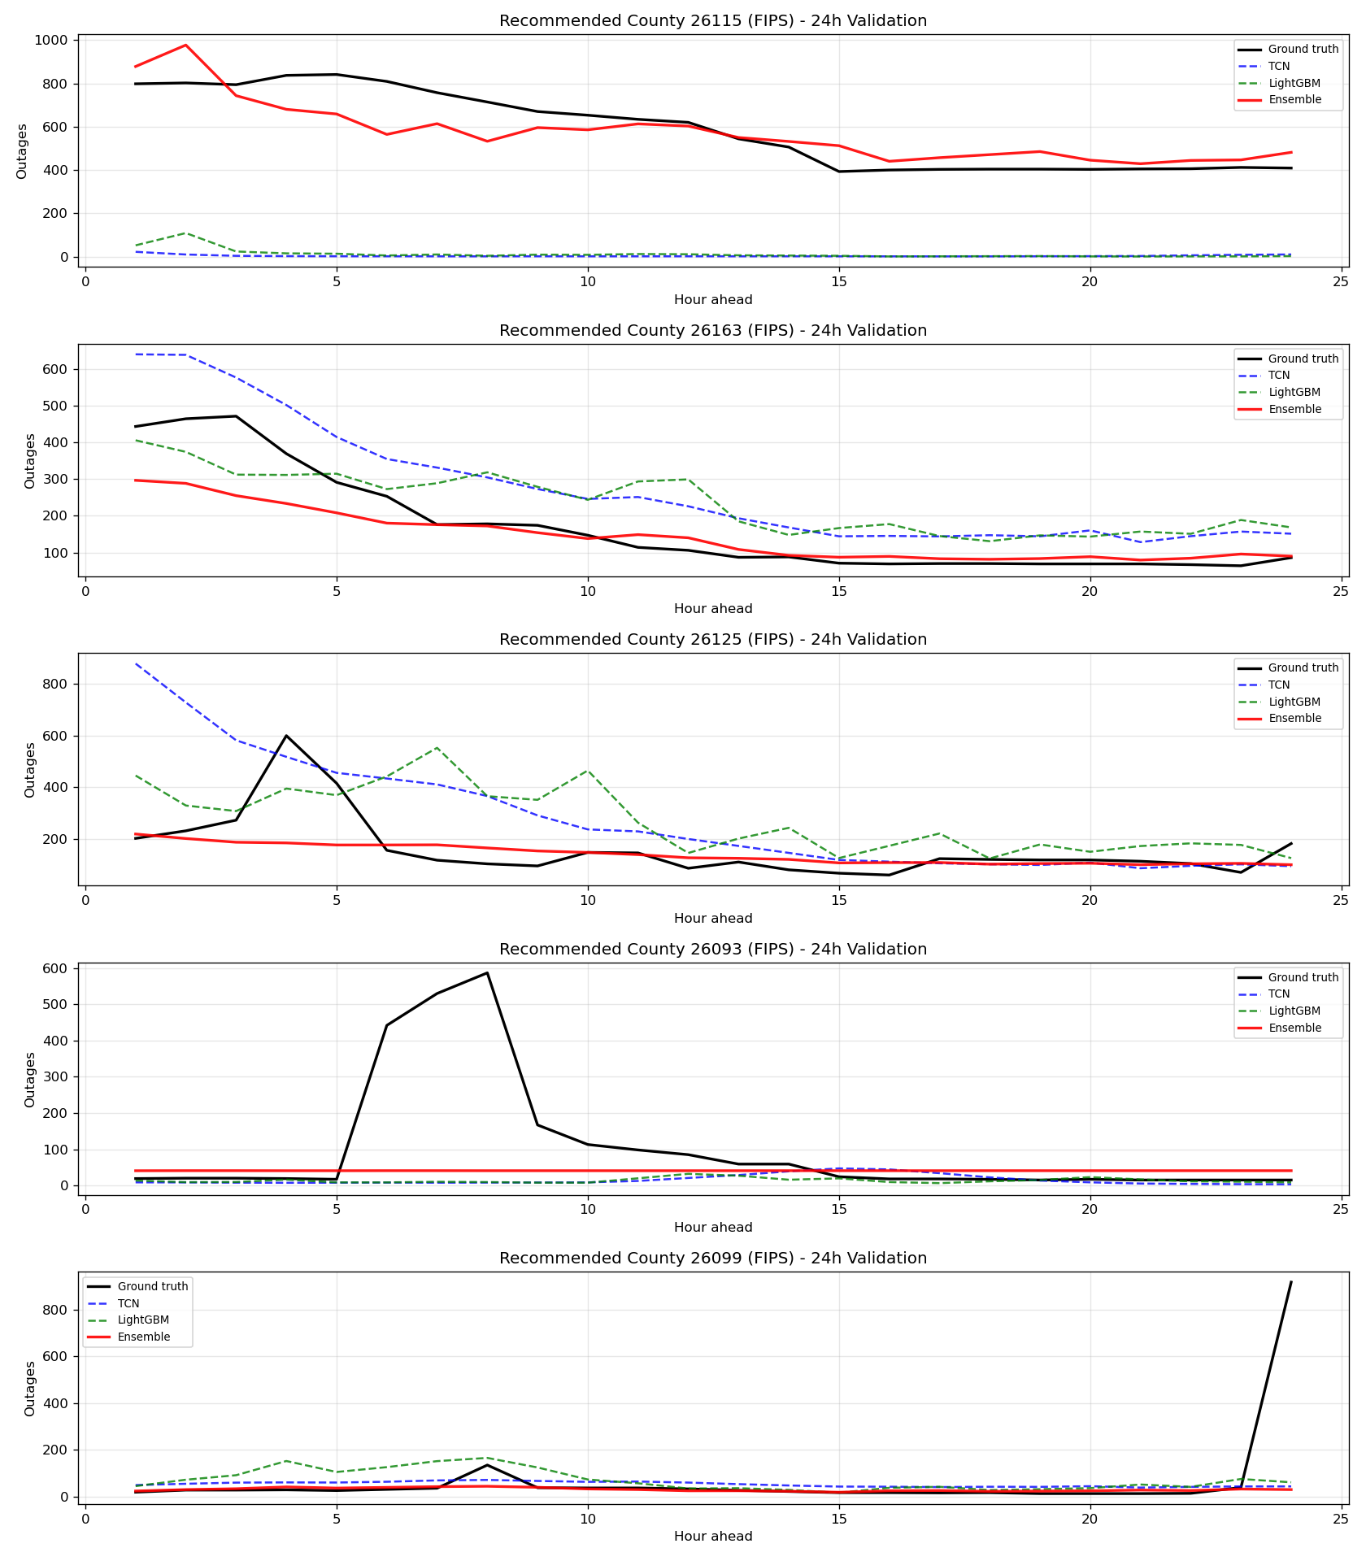
Figure 3. 24-Hour Validation Predictions for the 5 Recommended Counties

Model | 24 Hr RMSE | 48 Hr RMSE
Zero Baseline | 24.2307 | 25.5203
SARIMAX | 33.4974 | 35.8882
TCN | 22.4845 | 22.9170
LightGBM | 21.8161 | 22.8507
Ensemble | 14.2387 | 19.1820

Table 1. RMSE Table for Various Models

Model | Spike RMSE
Zero Baseline | 519.29
SARIMAX | 352.95
TCN | 499.73
LightGBM | 476.13
Ensemble | 254.76

Table 2. Spike RMSE (24 hr only with threshold > 162 outages)

Rank | County | FIPS | Tracked households | Served 24h | Served 48h | Score
1 | Monroe | 26115 | 75,792 | 8,243 | 10,414 | 1.000
2 | Wayne | 26163 | 922,402 | 4,271 | 10,722 | 0.443
3 | Oakland | 26125 | 618,059 | 3,005 | 5,848 | 0.279
4 | Livingston | 26093 | 90,499 | 1,001 | 11,397 | 0.276
5 | Macomb | 26099 | 413,681 | 1,051 | 10,010 | 0.252
6 | Washtenaw | 26161 | 174,441 | 114 | 3,897 | 0.082
Table 3. Top Recommended Counties for Backup Generator Pre-positioning

